

Electronic Horizon Most Probable Path
Algorithm Description Document

Revision 0.61

May 27, 2014

Change Control

Revision | Revision Date | Author / Modifier | Description / Modifications | Sections Affected
0.5 | 28 Mar 2012 | Aking6 | First draft | All
0.6 | 17 Dec 2013 | Dherman/ aking6 | Added support for Stub Expansion | 2, 10
.61 | 27 May 2014 | DHERMAN | Added logic for better expansion along slow moving freeways | 5

Table of Contents

1 References 4
2 Introduction 5
3 Horizon Expansion and Most Probable Path (MPP) 7
4 Basic Data Structure 8
5 Horizon Depth 10
5.1 Algorithm 10
5.2 Horizon Provider procedure 10
5.3 Application procedure 10
6 Horizon construction algorithm 11
7 Vehicle transitioning 18
8 Computing Horizon Weights 23
8.1 Turn Angle Transition Factor 24
8.2 Turn Time Transition Factor 25
8.3 Functional Road Class Difference Transition Factor 26
8.4 Outgoing Road Significance Transition Factor 27
8.5 Preferred Route Segment Transition Factor 27
9 Combining Different Predictors 29
10 Concluding Remarks 30

References

Section |  | Document | Revision
Function | Implementing an Electronic Horizon Engine Using Most Probable Path and Stubs Only (HorizonExpansion-MPP.doc) |  | Oct 15, 2010
Function |  | Dynamic Computation of Electronic Horizon Length (Dynamic Computation of Electronic Horizon Length v1.doc) | V1, Oct 25, 2010
Function |  | Durekovic, Sinisa (NAVTEQ); ADASIS v2 Protocol, 2011; ERTICO ITS Europe. | Rev C, June 2011

Introduction

Automotive industry has introduced the concept of electronic horizon as a way to provide applications with digital map data. This is represented by a software component that is able to predict where the vehicle is heading, extracts information from the digital map about the road ahead, and broadcasts it to the interested applications. This is the so-called Electronic Horizon.

Although there is substantial information regarding digital map data, the electronic horizon engine usually remains a mysterious component. The goal of this report is to reveal how such modules typically work internally. This includes a simple estimation of the road predictor, internal structure representation, and updating of the horizon as the vehicle travels.

This report does not intend to provide neither a reference nor a series-ready implementation, which typically employ numerous optimization techniques outside the scope of this work. However, the general concepts and foundations are still the same and should give the reader a good overview of what difficulties, shortcomings, and trade-offs are involved when deploying an electronic horizon in a commercial vehicle.

Electronic Horizon data typically comes in two forms. One is the full horizon, which represents information about every possible path that may be reached by the vehicle. The second one is the most-probably-path only (MPP), which denotes only the road that is most likely to be taken by the driver.

This document will focus on a hybrid of both, called MPP with stubs. This form of EH is essentially an MPP-only, but with information about road intersections. This hybrid approach is the most interesting type of each EH for most ADAS applications because it provides a good compromise between efficiency and most relevant information.

This document will also discuss MPP with first level sub-paths. This extends information around the intersection with a limited amount (length) of information about the roads off these intersections. This is useful for applications which are sensitive to "blindness" when the vehicle leaves the main path; (Durekovic, 2011) since information about the sub-path already exists for use, the application can still perform as the MPP recalculates and the horizon gets filled. Note that from the application side, the sub-path information does not have to be stored if it is not used; rather this data can be ignored and the application only needs to store the MPP with stubs data.

Horizon Expansion and Most Probable Path (MPP)

The electronic horizon (EH) engine is the module responsible for keeping track of what the road network ahead of the vehicle looks like. It stores information about those road segments that are likely to be reached within a specified distance, travel time, likelihood, or a combination of them. By focusing only on those segments that are most likely to be taken, the algorithm can reduce the computational requirements from exponential to linear. This is particularly important for deep electronic horizons.
As the vehicle travels forward, road segments are left behind and new ones are added to the electronic horizon. This process is called horizon expansion and will be described in section 5.
In order to predict where the vehicle is going in the future, the engine needs to know the likelihood associated to each possible turn. The weight associated to each turn or transition depends on many factors and may be computed in several ways. One of the simplest methods is based on a set of single-variable weight functions. Such an implementation is described in section 8.
As a result, the EH engine delivers a collection of road segments that are reachable from the current vehicle positioning, and how likely is that it eventually travels there. This report will describe the most probable path with stubs version, which concentrates on the single path that is most likely to be taken (MPP), along with information about crossings. EH can later extract additional information along MPP such as geometry, radius, speed limits, and countless road attributes that are of interest to applications.

Basic Data Structure
Current implementations of digital map databases represent the road network using basic units called links. A link is a road segment of arbitrary length, ranging from a few to several hundred meters. A link does not provide any information regarding the shape of the road, but rather how it connects to other road segments. Map databases typically break a road into links in order to represent intersections, changes in road characteristics –i.e. a road that suddenly becomes a highway– or simply to split a long road segment into smaller parts.
The EH engine is typically implemented using a tree structure, where each node in the tree represents a link in the map database. The root node of the tree represents the link where the vehicle is currently located. A transition from one link to a reachable successor is represented by adding a child to the proper parent node in the tree. This is important because as the vehicle travels forward, nodes that become unreachable are removed from the tree; however, we only want to remove those paths that are not reachable anymore. Examples of this data structure will be shown in sections 6 and 7, along with their equivalent map network.

Every time the vehicle transitions from one link to the next, at least one node becomes unreachable and will be removed from the graph. If the current link has more than one successor, additional nodes or branches may require removal. This process will be described in section 7.
EH is expanded along the most probable path until reaching to a termination criterion. This is typically a combination of depth, and likelihood of reaching the node in question. In out case, since we only care about the most probably path and intersections, the algorithm will not traverse through branches that are not part of MPP. This algorithm will be described in the next section.
The following road network will be used as an example throughout this document. The beginning and end of a link is delimited by red circles and are assigned names with letters. The length of each link is also shown below the link name. the white arrows denote the direction of traffic. The vehicle starts at link A.

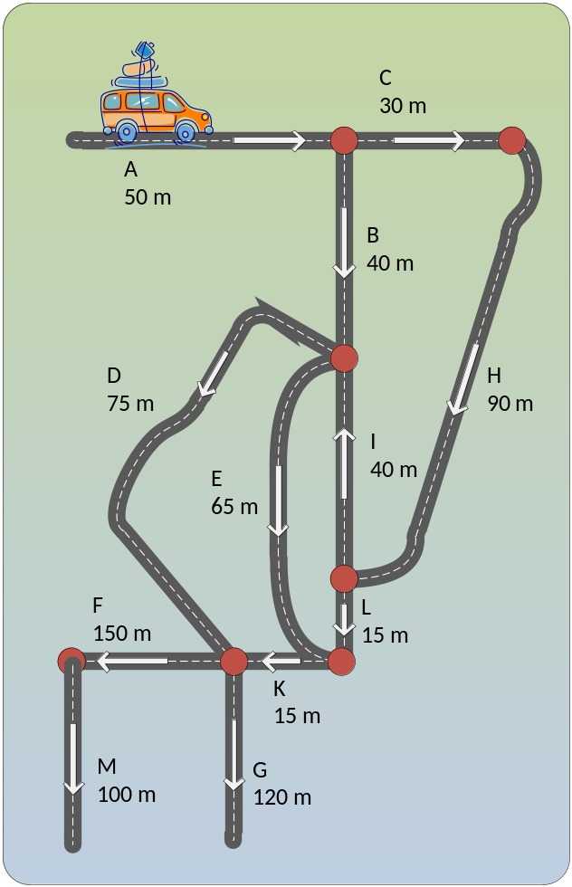

Horizon Depth
The horizon depth shall vary according to vehicle speed, and essentially allow the minimum horizon to be based on a "min time ahead". This is set by the configuration variable "Horizon Depth Scale Factor".

Algorithm
The following algorithm is proposed to calculate the minimum horizon depth.
- Compute mean vehicle speed from by averaging speed values from the last 3 position messages. If less then 3 position messages have been received by the moment of calculation, the average speed value of the received messages is calculated.
- Round the mean vehicle speed to the nearest 10kph. Speed values less than 10kph are always reset to the 10kph value. Speeds higher than 200kph are reset to the 200kph value.
- Define the minimum horizon depth to be k meters for every 1kph of the rounded speed value, where k is the Horizon Depth Scale Factor.
- If the form of way indicates controlled access road, expand as if the computed mean speed were equal to the speed limit of that segment
For example, for k = 5, at speeds lower than 10kph the horizon length would be 50 meters, at 100kph the horizon will be 500 meters, and at speeds 200kph and higher the horizon length will be 1 km.

Horizon Provider procedure
On the ADASISv2 Horizon Provider (A2HP) side the following procedure is proposed:
- On the A2HP side the minimum horizon length is calculated each time a new POSITION message is sent. It is assumed the POSITION message is sent by the A2HP as the very first message just after the map matched vehicle position has been obtained, before reprocessing or sending any changes in the electronic horizon.
- Using the new minimum horizon depth, the updated electronic horizon is calculated. The new or previously unsent parts of the horizon are sent to the CAN bus. At the end of the transmission of new data, if the CAN bandwidth still allows, the last SEGMENT message is repeated with the offset corresponding to the farthest point on the most probable path relative to vehicle position.
- If the vehicle is decelerating and the previously sent electronic horizon completely encapsulates the new minimum electronic horizon (considering the vehicle movement), the A2HP sends no additional messages.

Application procedure
On the application side the following procedure is recommended to reconstruct the current horizon length:
- When starting, wait for the first POSITION message. Since position messages are sent by the A2HP as the very first message, they always indicate the start of a new message cycle. The speed value in the POSITION message is used to calculate the estimated minimum horizon length.
- Note, that since the A2HP and Adasisv2 Horizon Reconstructor (A2HR) are not guaranteed to start synchronously, the estimates for the first 3 POSITION messages obtained by the application may diverge from the real values used in A2HP. However, after that the values shall coincide.
- Ask the A2HR for the electronic horizon depth available based on incoming messages, particularly the redundant SEGMENT message. If this length is less than the minimum length calculated dynamically based on vehicle speed, the horizon was not yet completely obtained (since the last SEGMENT message is repeated with the highest offset for a given path, the A2HR is aware of the full horizon depth in this direction as soon as this SEGMENT message is sent by the A2HP).

Horizon construction algorithm
The electronic horizon tree is initially constructed by examining the possible turns ahead of the vehicle. At each intersection, the engine computes the likelihood of taking each turn. The branch corresponding to the most probably path (MPP) is traversed again recursively until a certain depth is reached, or until the likelihood of taking the specific road branch in question becomes too small.
The following notation will be used throughout this document:

Notation | Meaning
P(node) | Probability of reaching node through a specific path.
Weight(parent, node) or W(parent, node) | Weight or likelihood associated to turning from parent to a node.
Length(link) or L(link) | Length of a single link
TravelTime(link) or TT(link) | Estimate time to travel through link
TotalDepth(node) or D(node) | Total distance from root link to end of node.

The following pseudo code describes the EH construction process. Please not that this algorithm is for the creating of a horizon from scratch and not for incremental expansion. The incremental expansion and clean-up, which is required as the vehicle travels forward, will be described in section 7.

This algorithm builds the data structure using a function buildGraph shown further down. The function uses a structure Node for keeping the tree information up-to-date. This structure can be as simple as

struct Node {
DatabaseLink id; // id that uniquely represents a link in the database
float probability; // probability of reaching this node

std::vector<Node*> successors;
};

When we start the application, or anytime the complete graph needs to be built from scratch, buildGraph is invoked. This will build the whole tree from scratch, until meeting a stop criterion. A pseudo-code implementation of the method buildGraph is shown next.

buildGraph() {
Node *root_node = new Node;

// these are global variables
global int travelDistance = 0; // stores distance until end of MPP
global int travelTime = 0; // stores travel time until end of MPP
global Node* end_node = root_node;
global Node* root_node = root_node;

end_node->probability = 1
end_node->id = global id in map database from the link corresponding to where vehicle is located;

travelDistance = Length(end_node->id); // get travel distance from database
travelTime = TravelTime(end_node->id); // get travel time from database

expand() // after this function call, current_node points to the end of MPP
}

The function expand() examines the last node in the tree, pointed by end_node, and attempts to expand it until reaching a termination criterion. If this function is called by buildGraph(), it will expand on the only node present, namely the root node. This will result in a rebuild of the whole tree.

expand() {
unsigned int startTime = GetSystemTime

while end_node->probability > minimum probability threshold
and travelDistance < maximum allowable travel distance
and travelTime < maximum allowable travel time
and GetSystemTime < startTime + maximum allowable computation time
{
// predictor engine returns non-accessible or non-legal children as well, but with P(child)=0
successor_list = ask the predictor engine for all immediate successors and weights from (end_node->id)

Node* MPPChild = NULL; // keeps track of MPP
float maxProbability = 0;
int ChildrenSum = 0

for each child in successor_list
{
// create new node and add them as children of current node
Node* newNode = new Node;
end_node->successors.push_back(newNode);

newNode->id = child;
newNode->probability = weightFromTo(end_node->id, child); // not normalized yet

// keep track of child with maximum probability
if newNode->probability > maxProbability {
maxProbability = newNode->probability;
MPPChild = newNode;
}

ChildrenSum = ChildrenSum + newNode->probability // accumulate sum
} // end for each

if ChildrenSum = 0
return // if no sucessors => we are done

// normalize
for each node in end_node->successors
{
node->probability = node->probability * end_node->probability / ChildrenSum;
} // end for each

current_node = MPPChild // move current link to MPP child
travelDistance := travelDistance + Length(MPPChild->id);
travelTime:= travelTime + TravelTime(MPPChild->id);

if MPPChild->id is already the id of another node in our MPP list
return // avoid cycles

} // end while
}

The expand algorithm attempts to address a few important remarks:
- The horizon starts at the node pointed by the global variable end_node. When expand is invoked by buildTree() it will start at the node with vehicle position.
- The algorithm requests the predictor engine for a list of successors from end_node, with their respective weights. Alternatively, the algorithm could look up by itself the successors in the database, and individually request Weight(parent, child) from the predictor engine. Depending on the software design, each approach presents advantages and disadvantages. The method shown here requires that the predictor has direct access to the map database, something that might not always be possible. On the other hand, it permits the predictor to optimize the computation by requesting all successors at once.
- The electronic horizon is expanded on the most probable path only, until a termination criterion is found. This is typically a low probability of reaching the node, a desired horizon length, or a desired travel time. Sometimes the algorithm introduces a maximum computation cap, in order to make sure that the system does not become unresponsive.
- Non-accessible and incoming one-way roads are also considered and added as successors from the end_node. This is important in order to detect intersections and their type. The predictor engine must return such links with an attached probability equal to exactly zero. Therefore, these links are not expanded further.
- Since weights are normalized as part of the algorithm, they may have an arbitrary range. Only their relative ratio is important.
- The algorithm that constructs the horizon is independent of the predictor engine. This may be implemented using a static predictor, a past-experienced based engine, route guidance, etc.
- If the MPP path contains a node more than once, the deeper instance of that node is not expanded, regardless of any other termination criterion. This restriction is imposed in order to prevent taking a path that goes in circles.
- After calling buildGraph(), the variables end_link, travelDistance, and travelTime store information about the node at the end of MPP, the distance required to reach its end, and the time require to drive there respectively. This will be needed for expanding the tree later.

The above algorithm will be shown with the road example shown in section 4.
First, we need to define some configuration parameters. Let's assume that the horizon has been configured with a desired length of 300 meters and a probability threshold of 0.10. This means that if the horizon depth has reached 300 meters or the probability of a link is below 0.10, the link in question will not be further expanded. In addition, the engine has been configured with a minimum length of 150 meters. This means that if the probability of a link falls below the 0.10 threshold but its depth is below 150 meters, it will be anyway expanded until reaching the minimum length.

The construction starts by taking current vehicle position and retrieving its link from the database. This becomes the root node A. Since this is the root node, it is assigned a probability of 1.0. The link has a length of 50 m.
P(A) = 1.0
Length(A) = 50
The algorithm requests the predictor engine for all successors from node A, with their respective weights. Determining weights is covered in section 8. The predictor returns two successors as follows.
Weight(A, B) = 600
Weight(A,C) = 400
The engine looks up their length in the database and finds out:
Length(B) = 40

Length(C) = 30
The total weight sum, normalized probabilities, and total depths are straightforward:
Sw(A) = 600 + 400 = 1000
P(B) = Weight(A, B) * P(A) / Sw(A) = 600 * 1.0 / 1000 = 0.6
P(C) = Weight(A, C) * P(A) / Sw(A) = 400 * 1.0 / 1000 = 0.4
TotalDepth(B) = TotalDepth(A) + Length(B) = 50 + 40 = 90
TotalDepth(C) = TotalDepth(A) + Length(B) = 50 + 30 = 80

The results of this first iteration are summarized in two tables below, and the same presentation will be used through the example at each traversal step.
The first is divided in two columns. The left column shows the Weights reported by the predictor, where W(X, Y) denotes the weight associated to turning from node X to node Y. Note that weights are only relevant among sibling of the same parent, and they do not need to add to 1 or 100. For example, if W(X, Y) is 75 and W(X, Z) is 150, all this says is that it is twice as likely to turn from X to Z than it is to turn from X to Y. If we later find that W(A, B) is 150, we cannot say that it is as likely to go from A to B as from X to Z, because we do not know anything about other siblings from A. this will become clearer as we go through the example. In addition to weights, the first column also shows the length of each successor as reported by the database.
The second column in the table depicts the calculations done to compute the probability of reaching each child based on the transition weights from the first column, and the total depth of the route that goes from the root node to each child.
The second table shows the map network and the internal graph data structure. Note that in the Map network information is placed on links, while in the graph structure information is placed on nodes.

Weight and  lengths from database | Computed probabilities and total length
W(A, B) = 600  W(A ,C) = 400  L(B) = 40  L(C) = 30 | P(B) = 600 * 1.0 / 1000 = 0.6  P(C) = 400 * 1.0 / 1000 = 0.4  D(B) = 50 + 40 = 90  D(C) = 50 + 30 = 80

Map network | Graph structure
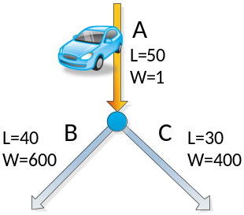 | 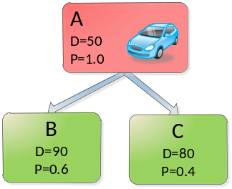

The algorithm picks the node with the highest probability, which happens to be B. The next task is to check whether it has met the termination criteria, or whether it could be expanded.
The total distance is 90, which is below the minimum length of 150. This is enough to satisfy the expansion criteria, regardless of the probability or maximum length.
The traversal discovers three children from B, namely D, E, and I. The last node however is a one-way road and therefore has a probability of zero. The results will be shown in the next tables.

Weight and  lengths from database | Computed probabilities and total length
W(B, D) = 85  W(B, E) = 15  W(B, I) = 0  L(D) = 70  L(E) = 65  L(I) = 40 | P(D) = 85 * 0.6 / 100 = 0.51  P(E) = 15 * 0.6 / 100 = 0.09  P(I) = 0 * 0.6 / 100 = 0  D(D)= 90 + 70 = 160  D(E)= 90 + 65 = 155  D(I)= 90 + 40 = 130

Map network | Graph structure
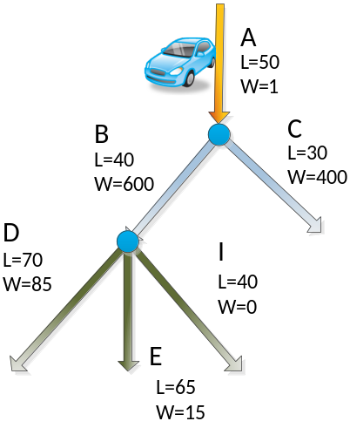 | 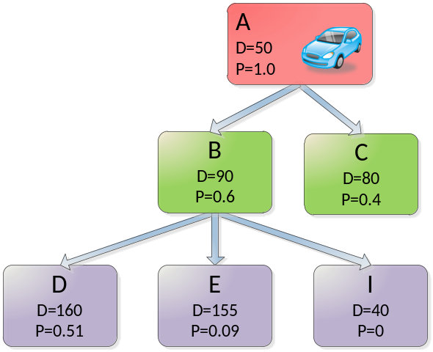

Next turn is for node D, which is clearly the one with highest probability. Its total depth TD(D) is 160, which is above the minimum distance of 150, so we check to make sure that it is below the maximum length and above the minimum probability.
Since P(D) > 0.1 and D(D) < 300, we can proceed to expand D.

Weight and  lengths from database | Computed probabilities and total length
W(D, F) = 200  W(D, G) = 30  W(D, K) = 0  L(F) = 150  L(G) = 120  L(G) = 15 | P(F) = 200 * 0.51 / 230 = 0.44  P(G) = 30 * 0.51 / 230 = 0.07  P(K) = 0 * 0.51 / 230 = 0  D(F)= 160 + 150 = 310  D(G)= 160 + 120 = 280  D(K)= 160 + 15 = 175

Map network | Graph structure
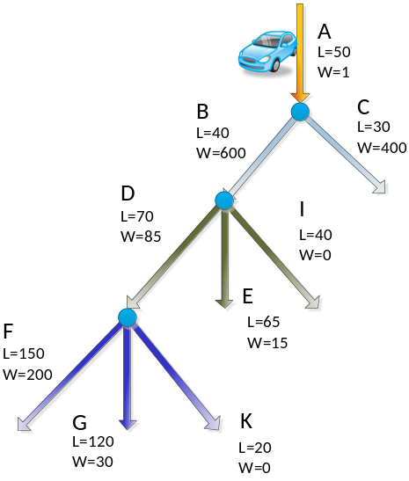 | 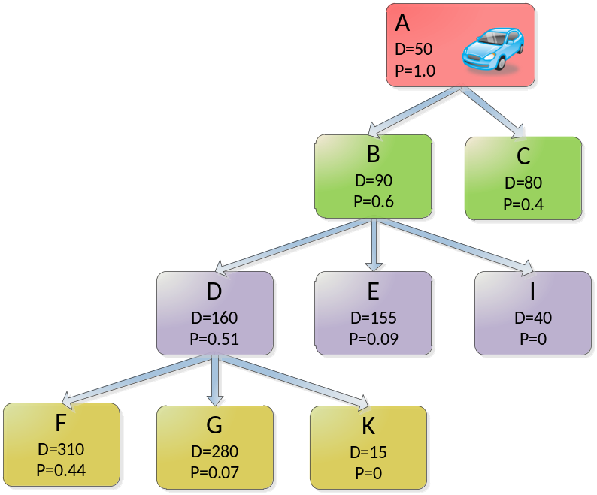

Most probable path is the transition to node F. Since D(F) is larger than the maximum depth, it is not expanded any further despite its high probability. This concludes the construction of the most probable path and its stubs.

Vehicle transitioning
When the vehicle transitions from one link to the next, it must be updated accordingly. Specifically, a transition will make certain links unreachable and new ones reachable. Let's take as an example the horizon constructed in section 6. The vehicle is located at node A and may go either to node B or C as shown below.

In general, two things can happen. The vehicle either transitions to the correctly predicted path —the MPP branch—, or to a link that was not expected. The former case is the interesting one and will be discussed below. Missing the path requires clearing the tree and rebuilding the graph from scratch, as we have done in the previous section.
Let's assume that the vehicle happens to transition node B. The first obvious fact is that node A is no longer reachable. In addition, all children from A that are not part of the MPP are unreachable as well as shown below. In our case this is just node C.
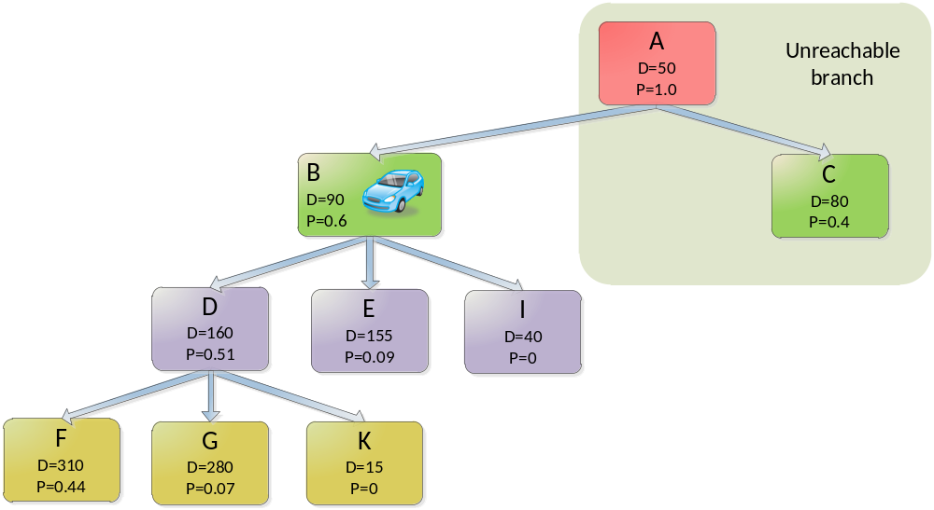
Updating the tree requires a series of steps, which are done by the method transition(new_root_id). This function takes a single argument, the link id that uniquely identifies in the database the road segment to wich the vehicle has transitioned. In our case, this would be the link id of node B.

The function first removes all children that are now unreachable. Then, it adjusts the probabilities and depths along the MPP branch. Last, it removes the root from the tree and makes the transitioned node our new root.
It is important to note that a vehicle may only transition from the root node to a child of the root. If this is not the case, the algorithm will handle the transition as invalid. This will lead to a complete reconstruction of the tree from scratch, just like as if we had miss predicted the path.

The transition function is shown below:

transition(DatabaseLink new_root_id)
{
Node* MPPChild = child from root_node with highest probability; // root_node is a global variable

// check if we have missed MPP
if MPPChild->id = new_root_id
{
for each node in root_node->successors // go through each child
{
if node->id = new_root_id // if this node is the reachable branch
{
Adjust(new_root) // fix probabilities of children
}
else
{
delete (node) // remove unreachable node
}
} // end for each

// adjust root node
delete(root_node);
root_node = new_root;

expand(); // grow the end node again
}
else
{
// we have missed the MPP
ClearWholeGraph(root_node); // delete everything
buildGraph () // rebuild
}
}

All children from the old root are processed. The ones that are unreachable are removed. The remaining one and its sub-children get their probabilities and depths adjusted, to reflect the effects of removing the old root. This is done via the method adjust. The travel time and distance to the last node is also adjusted.

adjust(Node* new_root)
{
Node *nodePtr = new_root
factor = new_root->probability;
offset = Length(root_node->id); // check in database for node length

nodePtr->probability = 1

while nodePtr->successors not empty
{
for each node that in nodePtr->successors
{
node->probability = node->probability / factor;
node = child of nodePtr with highest probability // move to next node along MPP
} // end for each
} // end while

travelDistance := travelDistance – TravelDistanceD(root_node->id) // check in database for node length
travelTime := travelTime – Length(root_node->id) // check in database for travel time

} // end function

In our example, the method adjust updates the probabilities after transitioning from node A to B as shown below.

Computed probabilities and total length
Factor = P(B) = 0.6
Offset = L(A) = 50

P(B)_{new} = 1
P(D)_{new} = P(D)_{old} / factor = 0.51 / 0.6 = 0.85
P(E)_{new} = P(E)_{old} / factor = 0.09 / 0.6 = 0.15
P(F)_{new} = P(F)_{old} / factor = 0.44 / 0.6 = 0.73
P(G)_{new} = P(G)_{old} / factor = 0.07 / 0.6 = 0.12

After applying the above algorithm, the network and tree structure looks like shown below:

Map network | Graph structure
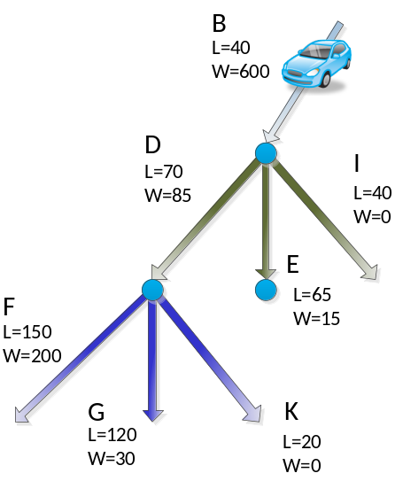 | 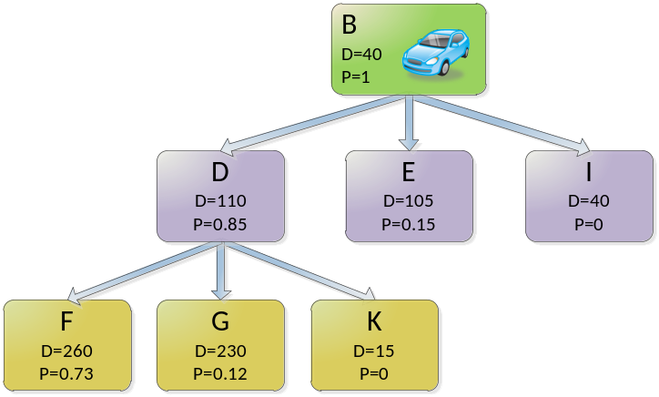

The interesting part after the adjustment is that now node F, which had been not expanded due to the termination criteria, is now suitable for further expansion. The algorithm does this by simply calling the method expand() used for building the tree. This method is called at the end of the transition() function shown above.

Expand will now extend F. The only successor returned by the predictor is M.

Weight and  lengths from database | Computed probabilities and total length
W(F, M) = 100  L(M) = 100 | P(M) = 100 * 0.73 / 100 = 0.73  D(M)= 260 + 100 = 360

Map network | Graph structure
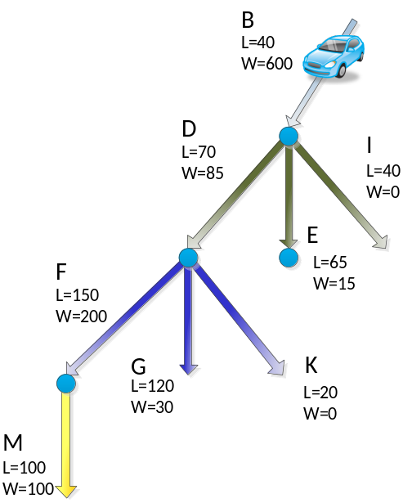 | 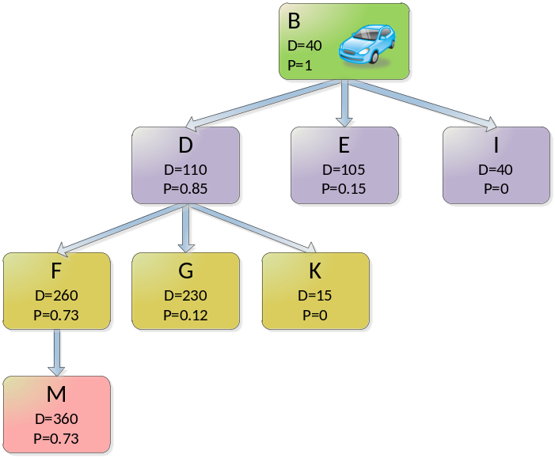

Due to its depth of 360, node M can't be extended any further. This concludes the transition from node A to node B.

Computing Horizon Weights
The most probable path is constructed, as shown in Section 3, by selecting the link path having the greatest aggregate probability compared to other candidate link sets. The probabilities represent the cumulative likelihood of the vehicle traversing a certain set of links, where at each node transition, it is necessary to determine which child link the vehicle is likely to take. The first example of Section 3 shows a vehicle on link A, with two candidate child links, B and C.

Map network | Graph structure
S

where
P(B) = Weight(A, B) * P(A) / Sw(A) = 600 * 1.0 / 1000 = 0.6
P(C) = Weight(A, C) * P(A) / Sw(A) = 400 * 1.0 / 1000 = 0.4
is used to determine that the vehicle is most likely to transition to link B given W(A,B) > W(A,C).

In general practice, the method to determine the transition weights is based on five transition factors as listed below. Detailed description is provided in following sub-sections.
- Turn Angle (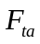) is the heading angle change required to make the transition. Going straight is given higher weight compared to turns.
- Turn Time (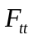) represents the estimated time to make the transition. Shorter turn time values are given higher weight.
- Functional Road Class Difference (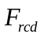) compares the current road class with the candidate link. Transitioning to a more major road class is given higher weight than to a more minor road class.
- Outgoing Road Significance (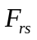) represents the category (size) of road for the candidate child link. As an example, highways are given higher weight than side streets.
- Preferred Route Segment (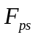) allows a route, such as from a navigation system, to place weight on a link that is part of the route.

Transition weighting is then calculated for each candidate link according to:
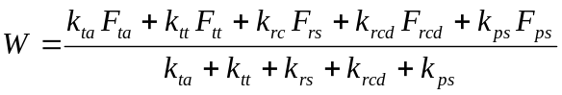

The overall transition weight  and transition factors 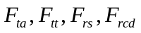 and have values over the interval 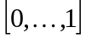. In the example above from Section 3, the transition weights have been multiplied by 100.

The variables 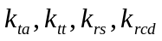and 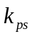represent configurable parameters that allow the respective turn angle, turn time, outgoing road significance, road class difference and preferred route segment to be tuned to achieve desired overall weighting performance. The tuning parameters are also . To turn off the influence of a particular transition factor, the corresponding tuning factor is set to zero, and likewise, to maximize influence, the tuning factor is set to one. For the preferred route segment tuning factor to have appreciable influence, set such that 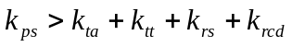.

Turn Angle Transition Factor
The turn angle transition factor makes the assumption that the driver is likely to make a minimum of turns, and that taking the road link that continues in the current vehicle heading is favored. The turn angle required to follow the candidate link is calculated as:
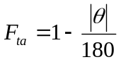
where is the angle between the parent link and the candidate link. As shown in the figure below the turn angle from the parent link to the child link can be interpreted as either the angle difference between the parent exit node angle and the child entrance node angle , as the angle difference between the parent link exit node and the child link exit angle , or the angle between the parent link exit node and the child link exit node from a position point of view, .

N
E
α
β
γ
Link start/stop
Internal shape point
Parent Link
Child Link

When shape points exist, the child link entrance and exit angles are measured using the angle between the node and the nearest shape point. So, in the example above, (measured using the shape point closest to the child entry noe) is a relative small angle since the child link departs the parent link by a small angle. In contrast, (measured using the child exit note and the closest shape point) is a larger angle in comparison to . However, while is a possibility to use for , it can be ambiguous for ramps that have exit node angles equal to the exit node of the parent link, therefore is not advised. It is advised to use for the turn angle .
For a child link that has no shape points (a straight link), 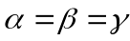, therefore, is unique.
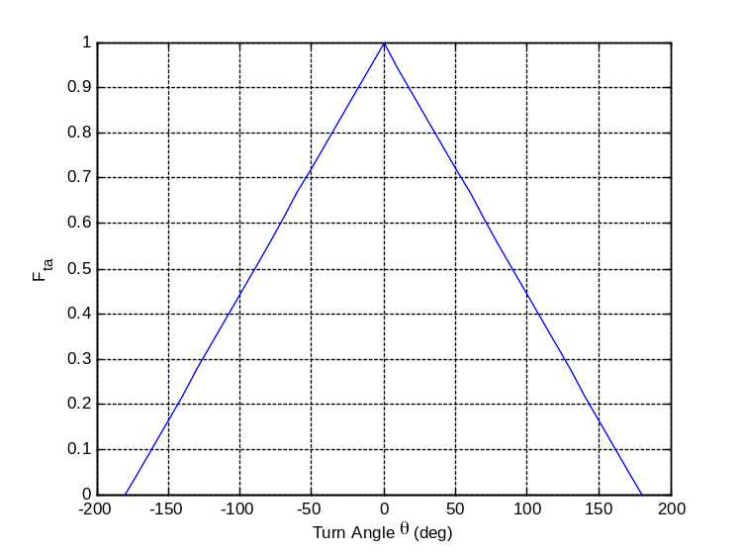
Turn angle transition factor

Turn Time Transition Factor
Turn time transition factor makes the assumption that drivers will take transitions that avoid long delays in making a turn. The turn time factor is computed as:
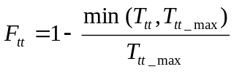
where 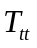 is the turn time in seconds extracted from the map database. The tunable parameter 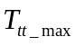 is the turn time beyond which is zero. If the map database does not contain turn time information for the given transition, it will return = 1, making approximately one. If turn time is not available in general, it is advised to set the tunable parameter 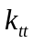to zero.
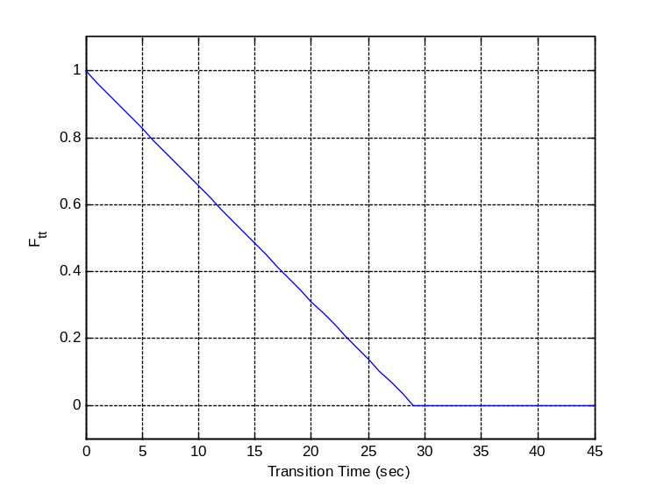
Turn time transition factor

Functional Road Class Difference Transition Factor
A link functional road class difference represents an approach to a forming a transition factor based on the assumption that the driver will seek the transitions that lead to using a more major road type during a journey. The road type is defined by functional road class defined on the interval [0,…,5] as specified in the ADASIS interface specification for the Segment message. Functional class type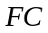 0 represents the interstate freeway or autobahn type road to 5 representing residential streets. Road classes spanning the range of values will be assigned by the electronic horizon provider.

Increased weighting will be assigned to transitions that lead to lower (major road) values, and decreased weighting will be assigned to transitions that lead to higher (minor road) values. The relationship to the transition factor is formed by first calculating the difference in values between the parent link 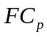and the child link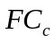,

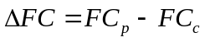

is then determined from a table look up based on 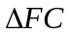.

look-up table for difference in functional road class
< -1 | 0.1
-1 | 0.2
0 | 0.5
1 | 0.7
> 1 | 1.0

Outgoing Road Significance Transition Factor
The child link (outgoing link) significance is used to provide weighting based on a continuum of road types. The road significance factor is similar to the functional class difference factor in that both favor major road types over minor types. The road significance factor allows for a greater number of road types to be considered, and weighting to be manipulated between the candidate links.

Form of Way | Route Number Types | Transition Factor
8,9,10 (Ramp) | (ignored) | (29-FC)/100
11,13 (Service) | (ignored) | (19-FC)/100
12 (Parking) | (ignored) | (09-FC)/100
All other | RT1 – RT6; In Europe (except Ireland) RT1 – European street has to be ignored, otherwise always use the highest set bit in the Route Number Types bit field. | (39 + n*10 – FC)/100,  where n is the sequential number of the route type counting reversely: n=7-RT  (e.g. 1 is RT6 and 6 is RT1)
All other | (Street with no route number) | (39-FC)/100

Preferred Route Segment Transition Factor
A route used by a navigation system can be used to bias the transition weight to select candidate links that lie on the route. There is no equation for . Recommended values are:

Link
On Route | 1.0
Alternate Route | 0.5
Otherwise | 0

Combining Different Predictors
The method depicted in section 8 for computing turn weights is based on the so-called static-predictor. This method is static in the sense that its outcome is based solely on parameters and attributes that do not change over time. That is, a static-predictor will output the same weights for the children of a particular successor regardless of the time of day, weather, or how often it is driven. This distinction makes static predictor relatively easy to implement and test, but the downside is that they repeat mistakes over and over. One typical scenario that tends to be problematic is exiting from highways. A static predictor will most likely miss highway exits, and it will do it every single time.
In order to compensate these deficiencies, predictors are often implemented by combining various sub-prediction engines. One popular combination is having a static predictor engine together with a predictor based on the turn-light indicator. The later one is used for predicting turns at the next intersection, while the former one is used thereafter.
Other predictor engines that can be combined or run as stand-alone are based on past-experience, seeking to learn how the driver uses his vehicle and act accordingly.

Combining different predictor is typically implemented by a weight function

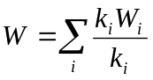

Where the index i identifies a predictor engine, k_{i} is a weight constant associated with the particular engine, and W_{i} is the turn weight estimated by the engine. The constant k_{i} is used to express the confidence of how well a sub-prediction engine performs and it could be modified during run-time based on learning or user input. For instance, if the system realizes that the past experience-based engine is performing poorly, such as in the case of utility vehicles, it could set this constant to a low value. Similarly, if the system realizes that the driver does not engage the turn-light indicator as often as he should, it could then adapt this constant to reflect this.
The combination of different predictor must be done in full awareness of when a predictor can contribute and when not. For instance, turn-light indicator predictor will often have a non-zero k_{i} in intersections directly ahead of the vehicle, and zero contribution thereafter. As the vehicle travels forward or the driver engages the turn-indicator, it might be necessary to dynamically update the turn-weights. The exact strategy is dependent on the particular engine and implementation. Some might update the weights and report them to the applications on constant basis, while other implementation might update the weights on constant basis but only report to applications if they modify the most probable path.

Stub Expansion
If stub expansion is configured on, the algorithm shall be modified to support the following concepts:
- Each non-MPP followed stub shall have a unique sub-path index. If the driver diverges from the current MPP, the follow procedure shall be followed:
  - Send a reset stub
  - then the new MPP PathID shall follow the pre-defined sub-path index
  - retransmit from the point on the new PathID that we connect to (retransmit flag=true) for any data previously sent
  - Reverse horizon is not provided
- Each non-MPP followed stub shall be expanded a minimum of 100 meters. If a stub is found within that 100 meters, you shall expand that stub as well (following subpath rules from above) up to 200m total distance from initial stub maximum (100/200m values shall be configurable via config file)
- Non-Accessible stubs shall be expanded
- Roundabouts and Complex intersections to be fully expanded (along rules from step 2)

Use Case:
The driver start on path 8, the expansion sees a stub and expands it (subpath 10). Subpath 10 is expanded to 100m. In so doing, it sees another stub (within it) and expands that to 100m. Each subpath is expanded with offsets starting at the stub as offset 0 for that path. If the driver diverges from the MPP (pathID 8) to subpath 10, a reset stub is sent
and then the mpp is broadcasted, with the postion message based on the prior expansion. such that if the driver is 50 m into the new stub, the first position message will start at 50, looking forward.
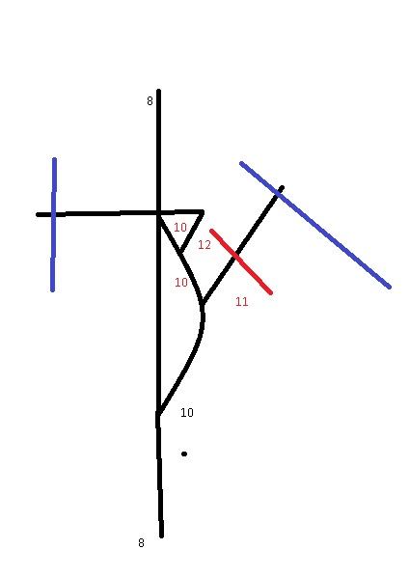

Concluding Remarks
This document provides a framework for the construction of an EH engine capable of delivering map attributes for road links from the vehicle future path. It has taken a close look at how an EH engine stores and processes these data under the hood, and how it reacts as the vehicle moves along the road.

We have seen how the upcoming path is predicted based on an exploration of the likelihood of the vehicle to take a particular set of connected road links in the road network compared to another set of road links. We have also looked at how weighting functions for links and link transitions are used to evaluate the likelihood of one path versus another, resulting in a most probable path.

This document detailed a possible algorithm describing how to search through the link network to find the minimal cost path given a set of weight rules and a desired horizon depth. The search algorithm can be adjusted to suite the needs of the applications using EH with regard to speed and completeness of search. The most probable path herein represents a static prediction based on weighting functions of map attributes alone. Other implementations could consider additional vehicle data in the weighting functions, such as turn signals and vehicle deceleration, to dynamically adjust weights used in the most probable path computations.

